**Name:** …………………………………………

**Class:** …………..

**REVISION FOR SEMESTER 2**

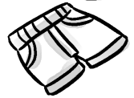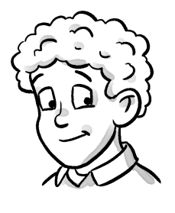**I. Look and read. Put a tick ☑ or a cross 🗵 in the box.**

**1.** He has curly hair. □ **2.** These are my socks. □

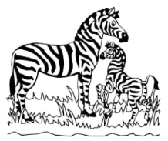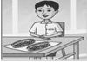

**3.** I have a sandwich. □ **4.** They’re giraffes. □

**II. Read this. Choose a word from the box. Write the correct word next to numbers 1-5.**

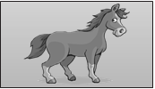**A horse**

I’ve got four ..…**legs**….. , two ears, two eyes and long **(1)** ………………………..

on my head. I’m a big animal. I don’t live in a **(2)** …………………………………

or a garden. I like eating **(3)** …………………………………… and apples. I drink

**(4)** ……………………… **.**

A woman, a **(5)** ……………………. or a child can ride me. What am I? I am a horse.

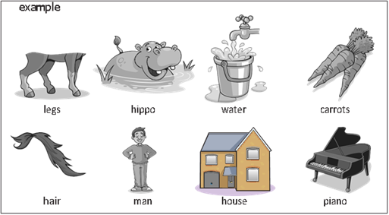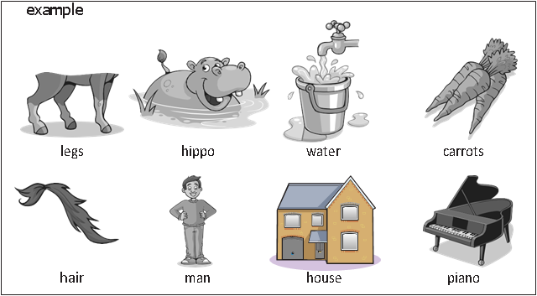



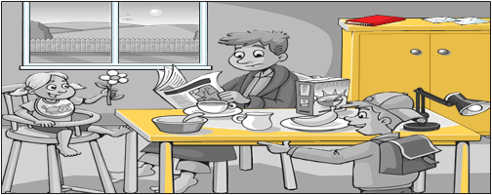**III. Look and read. Write *yes* or *no*.**

**1.** There are four people in the picture. _______________

**2.** You can see a lamp on the cupboard. _______________

**3.** The father is reading. _______________

**4.** The girl has got a flower in her hand. _______________

**5.** There are two bananas under the table. _______________

**IV. Look at the pictures and read the questions. Write one-word answers.**

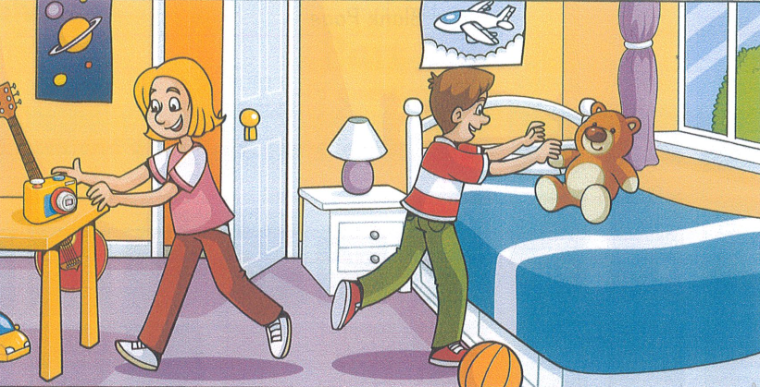

**1.** How many children are there? _______________

**2.** Where are the children? *in a* _______________

**3.** What is on the table? *a* _______________

**ĐÁP ÁN**

**I. Nhìn hình và đọc câu. Đánh dấu 🗹 hoặc dấu 🗵 vào ô trống.**

**1.** 🗸 **2.** 🗶 **3.** 🗶 **4.** 🗶

**II. Đọc đoạn văn. Chọn từ ở trong khung và điền vào chỗ trống.**

**1.** hair **2.** house **3.** carrots **4.** water **5.** man

**III. Nhìn tranh và đọc câu. Viết *yes* hoặc *no*.**

**1.** no **2.** no **3.** yes **4.** yes **5.** no

**IV. Nhìn tranh và đọc câu hỏi. Viết câu trả lời chỉ với một từ.**

**1.** 2 / two

**2.** bedroom / room / house

**3.** camera

**☺The end!☺**